William Spruyt

People focused with patience and willingness to learn.

contact

williamspruyt@hotmail.com

I put together this page to illustrate some of the qualities I have which might not be revealed by my CV.

Travel and Music

After graduating with a literature degree from the University of Manchester, I read and travelled widely. I worked overseas and taught in Poland, Japan and London. I met and collaborated with musicians to jam and perform where-ever I could, while living in London where we put on numerous gigs.

Grounded in Family

This was colourful and thrilling period of my life but nothing like as rewarding as getting together with my wife to raise my children. During this time, I took on roles which fitted in with my childcaring responsibilities, but I always maintained my love of learning.

Always looking to learn new things.

One positive life habit I have developed has been the use of the rich resources available for learning and self-improvement online.

A Case in Point

I wanted to know what Machine Learning really was, so I took an online Machine Learning Course, this made me want to understand what calculus really was, so I joined Khan academy to find out. I was initially dismayed to see how much I needed to learn in order to understand things like differentiation and regression but, after hours of study, I got there!

it's bang on twenty past nine

I created this human language clock with **JavaScript.**

I have a deep interest in pre-War blues and play the **guitar** as daily meditation.

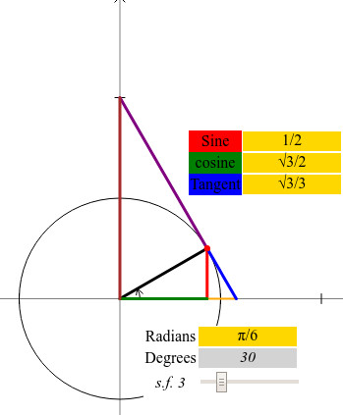

Unit Circle

I combined a fascination with **Maths**and an ongoing interest in coding and the **technologies of the web** to create this visual representation of the trigonometric functions.

TRY IT!

I take advantage of the free powerful digital technologies that are on offer today. For example, have used**blender 3D animation software** to participate several times in the online 3d animation competition 11 second Club here's one of my entries!

I spent a few years teaching English overseas. One of the countries I worked in was Japan where I acquired an interest in the Japanese culture, in particular classic Japanese Cinema. This has given me the desire to learn the **Japanese language** to the point where I can watch *The Seven Samurai* without the subtitles. With the help of Duolingo and other resources I might get there one day!

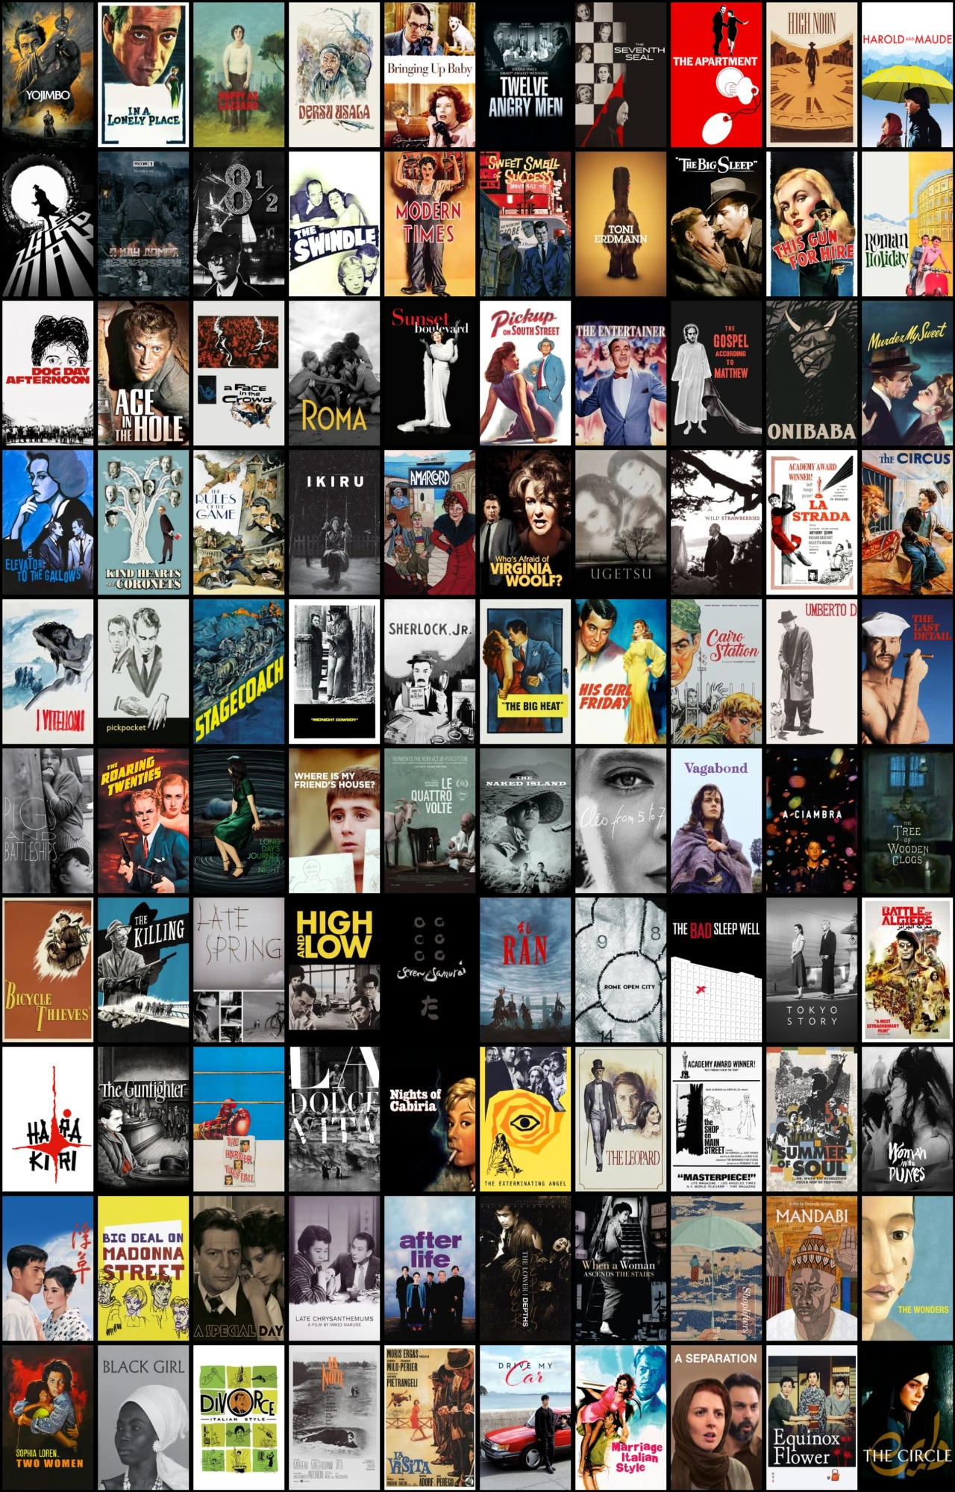

100 Flicks

My Wife and I share a passion for cinema from around the world and spent the lock-down compiling this list of our favourites. This is a web page built using the **React Framework**

[TRY IT!](https://100flicks.github.io/)

Page Design William Spruyt